Day 72

DIY

DIY Questions:

1.Write a docker file to create an image that hosts the below Html code?

vi index.html

<p>Welcome to Edureka!</p>

Solutions:

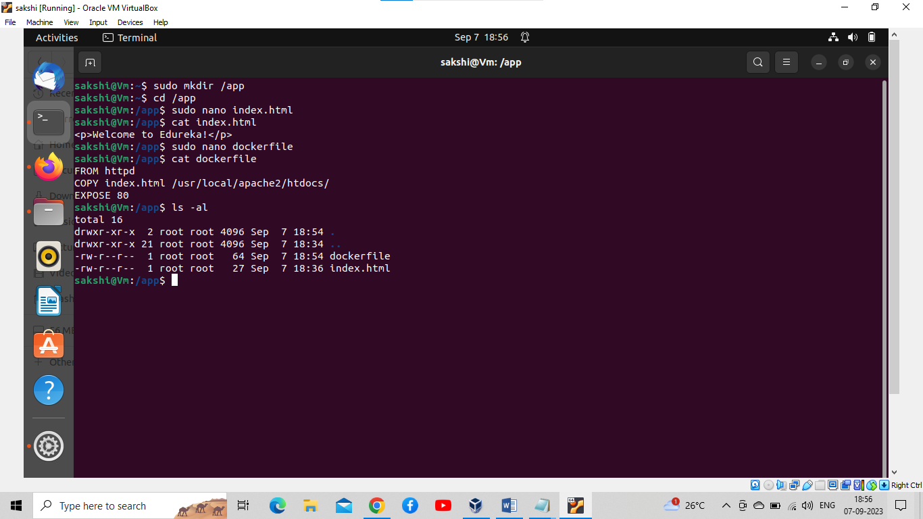

2.Write a command to build an image with the name welcome:v1 using the docker file created in the step above?

Solutions:

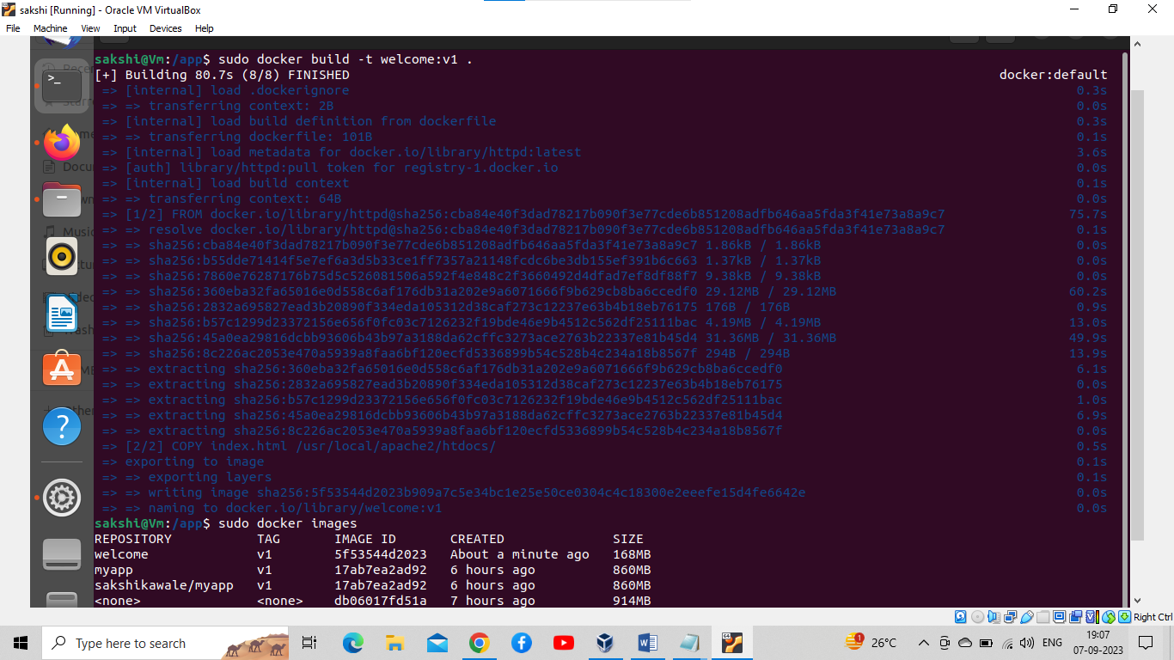

3.How to create a container using the above image(welcome:v1), expose it on port 30000, and check if the webpage is accessible?

Solution:

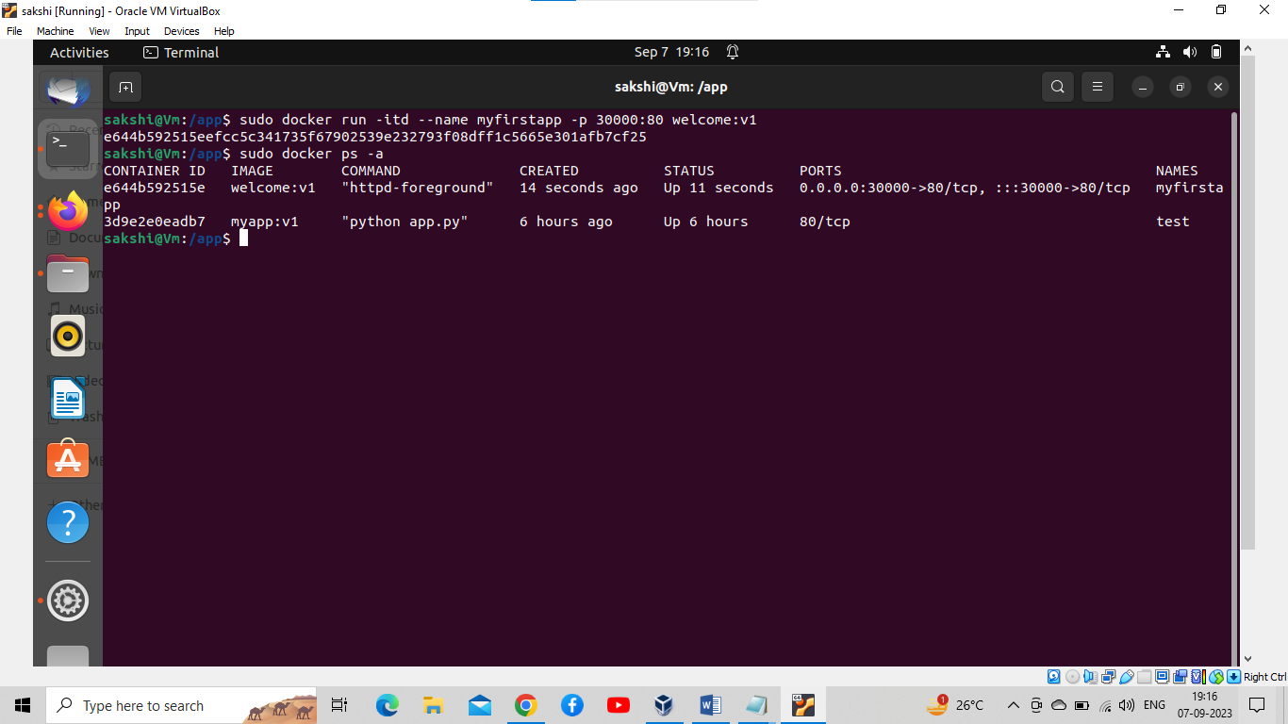

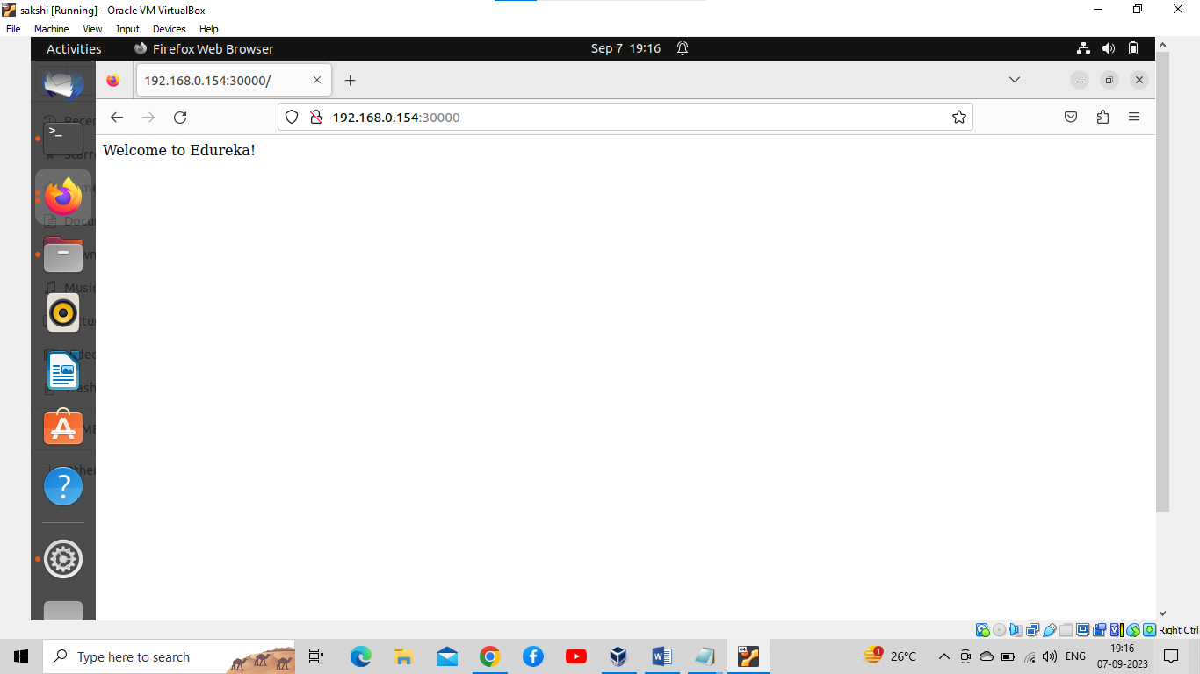

4.How to pull an image ubuntu:18.04 from docker hub, tag it with the name myubuntu:v18, and push it to your own account on docker hub?

Solution:

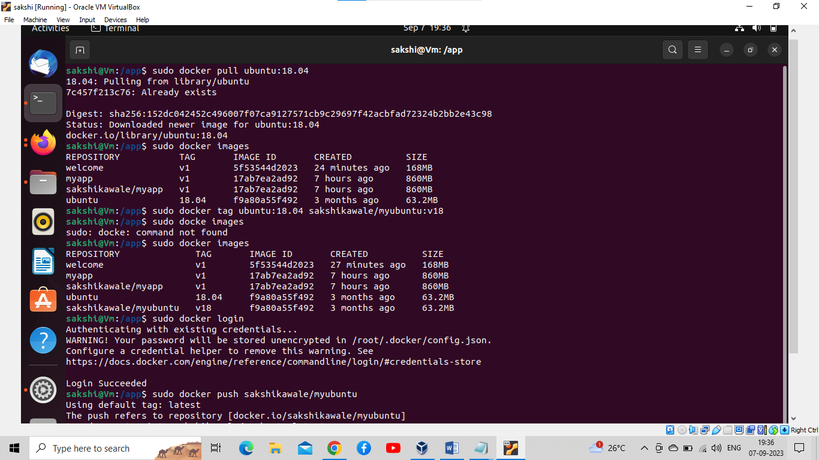

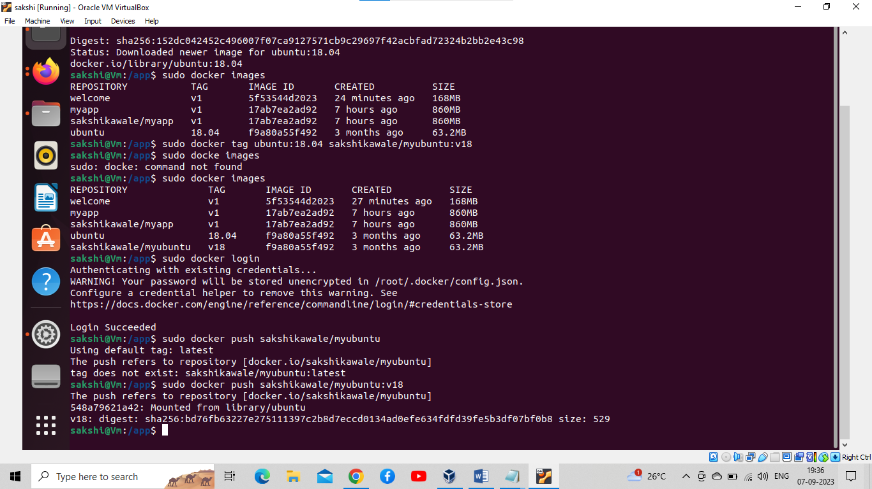

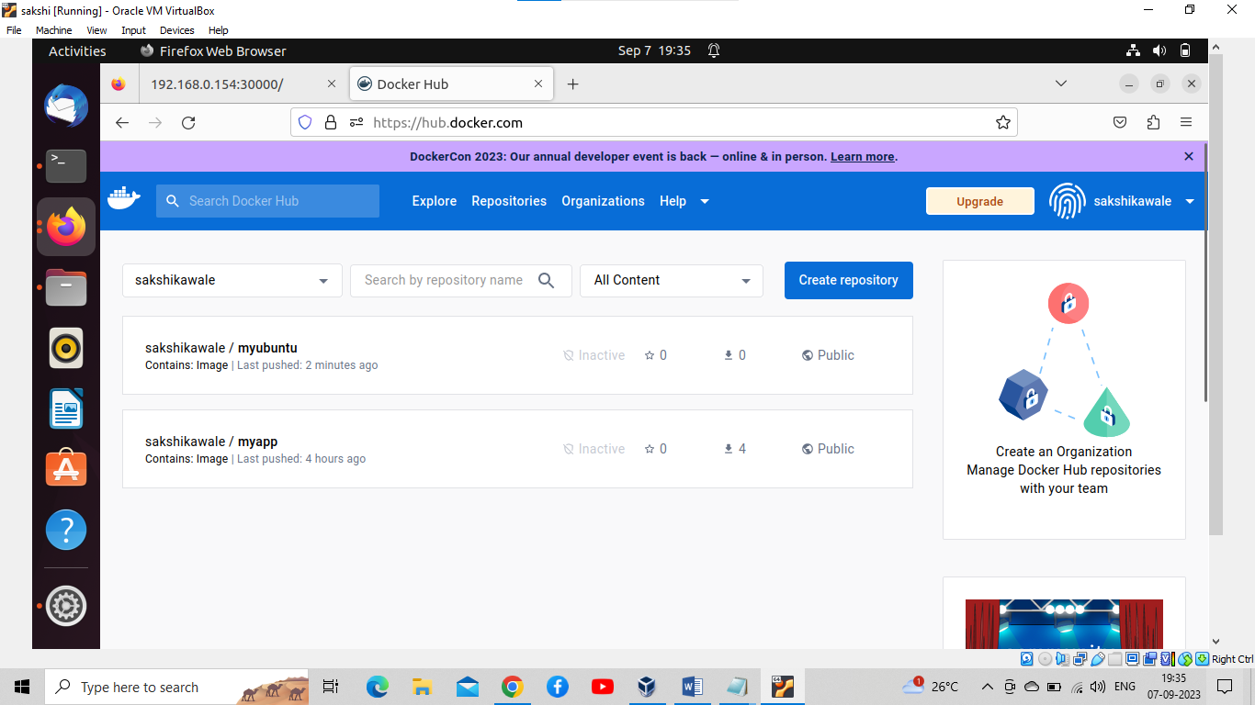

5.Name three essential characteristics of a Docker container image.

Solution:

Three essential characteristics of Docker container images are:

1. Immutable: Container images are designed to be immutable, meaning their contents cannot be changed once created. Any modifications require creating a new image layer, ensuring consistency and reliability.

2. Lightweight: Docker container images are lightweight because they share the host operating system's kernel. This makes them efficient to deploy and start quickly compared to traditional virtual machines.

3. Portable: Container images are highly portable and can run consistently across various environments, such as development, testing, and production, as long as Docker is installed. This portability simplifies application deployment and scaling.

6.What’s the difference between the ENTRYPOINT and CMD instruction?

Solution:

The main difference between the `ENTRYPOINT` and `CMD` instructions in a Dockerfile is how they handle command execution within a container:

1. ENTRYPOINT:

- Defines the executable that will run when the container starts.

- It is typically used for the main application or process in the container.

- Arguments provided at runtime are appended to the `ENTRYPOINT` command.

- If both `ENTRYPOINT` and `CMD` are used, `CMD` arguments are passed as arguments to the `ENTRYPOINT`.

2. CMD:

- Specifies the default command and its arguments for the container.

- You can override the `CMD` instruction by providing a command and arguments when running the container.

- If no `CMD` is specified, the `ENTRYPOINT` command (if defined) is used as the default.

In summary, `ENTRYPOINT` defines the main executable, and `CMD` provides default arguments. When running a container, you can override the `CMD` or provide additional arguments, but the `ENTRYPOINT` remains constant as the entry point for the container.

7.How will you create a Dockerfile that inherits from Ubuntu version 18.04 and that installs ping and runs ping when a container starts? The default address to ping will be 127.0.0.1.

Solutions:

